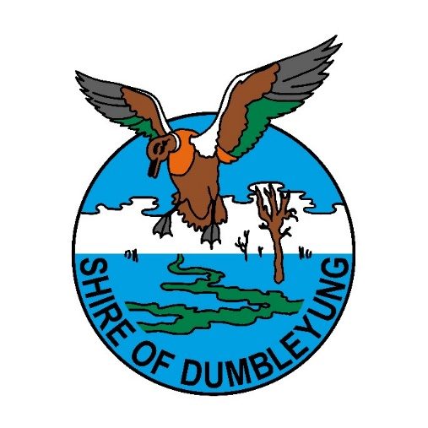

**SHIRE OF DUMBLEYUNG**

**MAINTENANCE GRADER / PLANT OPERATOR**

The Shire of Dumbleyung is looking for a suitably experienced person to join our close-knit team as a Maintenance Grader / Plant Operator.

The successful applicant must be in possession of a current HC Driver’s licence and be able to carry out various tasks in relation to road construction and maintenance, plant operation, and general duties.

Conditions of employment will be in accordance with the Level 4 of the Local Government Industry Award (up to $68,000 per annum) depending on experience and qualifications. The position also offers a 9 day fortnight with overtime often being available. Housing options will be discussed with the successful applicant.

Applicants are requested to submit their resume including two references and cover letter summarising your experience to [craig.elefsen@dumbleyung.wa.gov.au](mailto:craig.elefsen@dumbleyung.wa.gov.au) For further information regarding the position please contact Anthony Pearce, Works Supervisor on 0427 635 911.

Shortlisting will commence as applications are received.

**Gavin Treasure**

**Chief Executive Officer**

**Shire of Dumbleyung**

**PO Box 99**

**DUMBLEYUNG WA 6350**